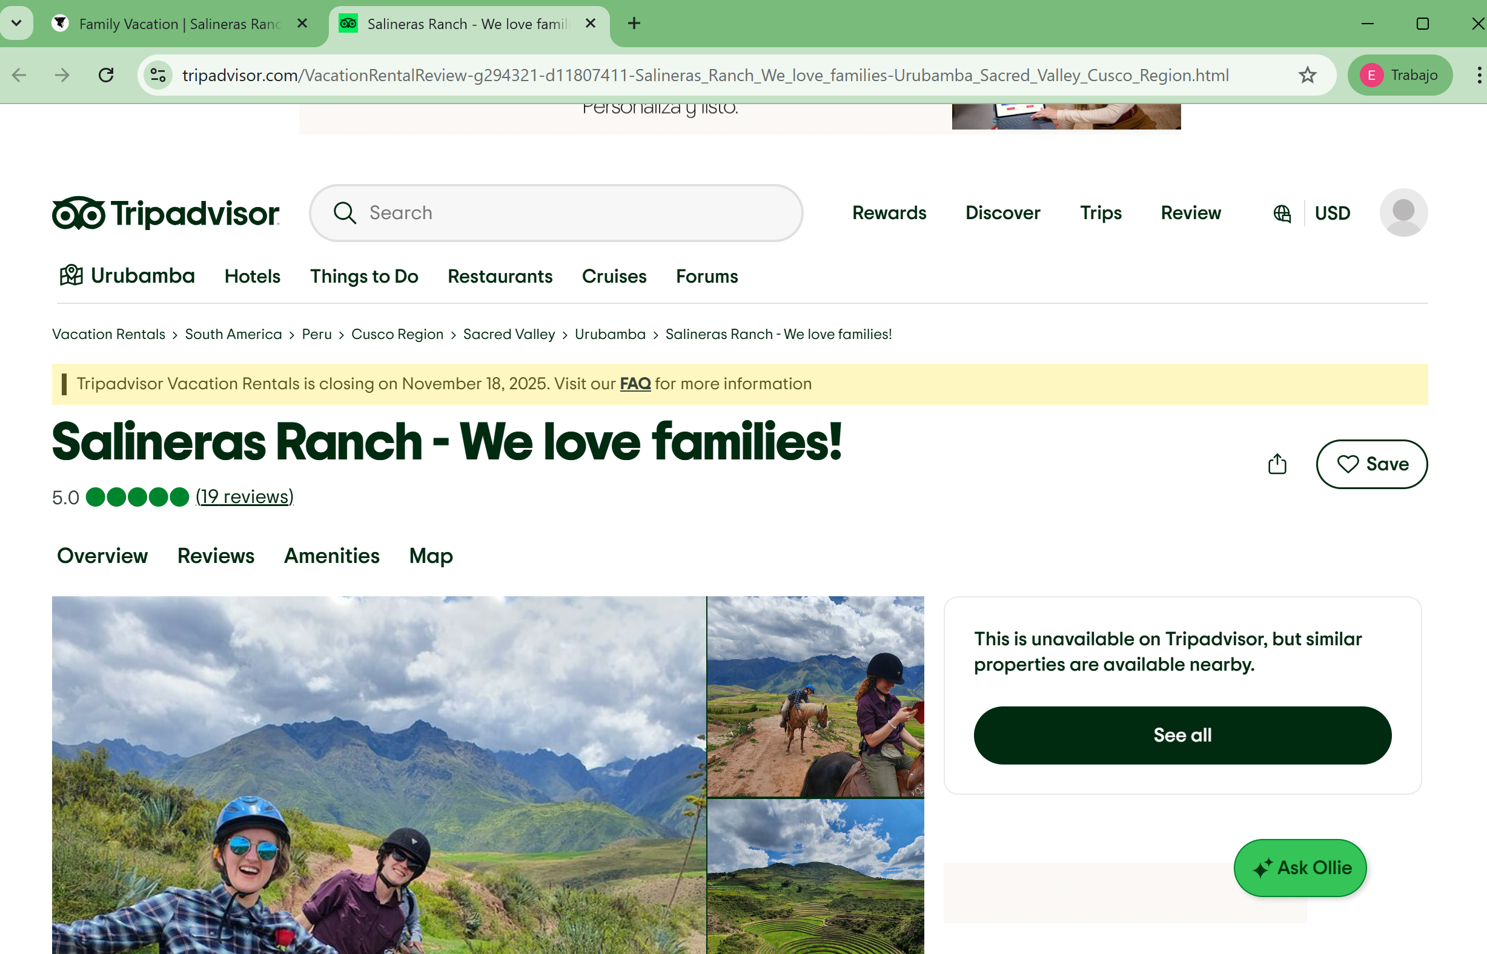https://www.tripadvisor.com/VacationRentalReview-g294321-d11807411-Salineras_Ranch_We_love_families-Urubamba_Sacred_Valley_Cusco_Region.html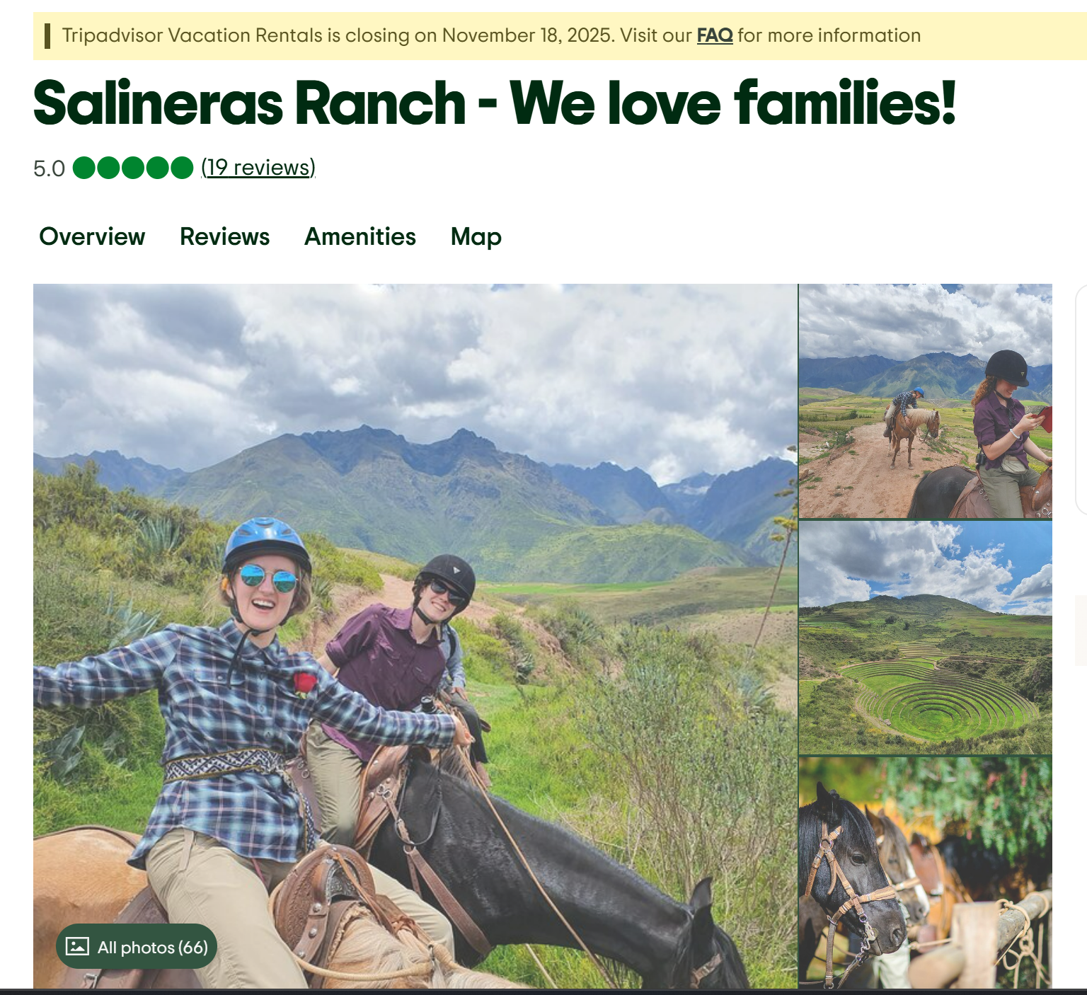

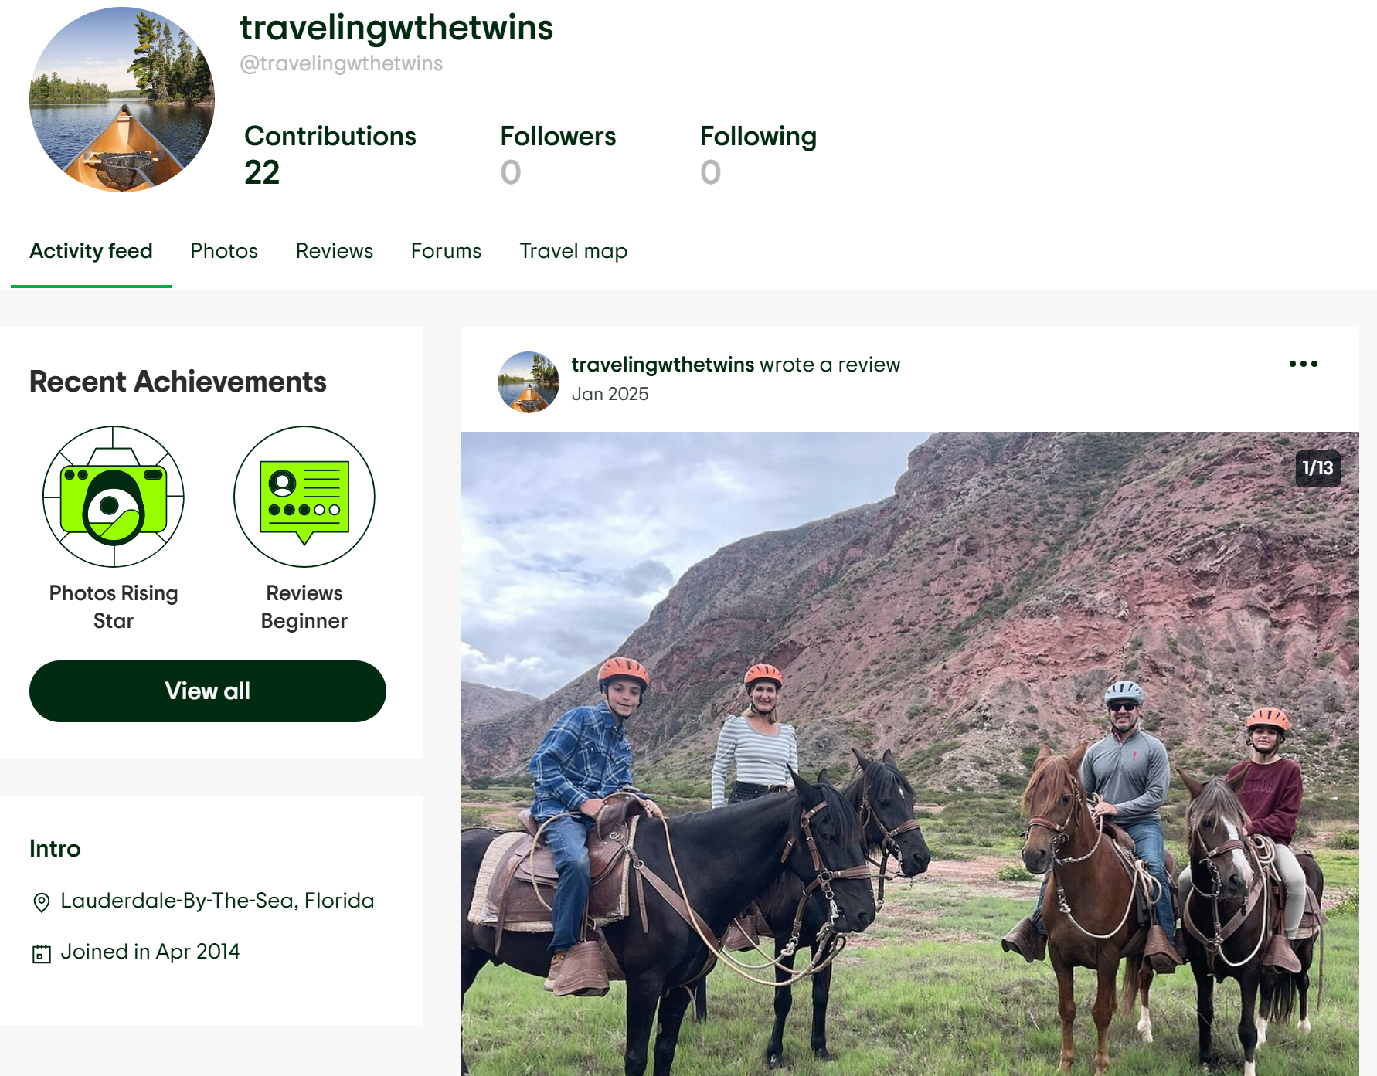
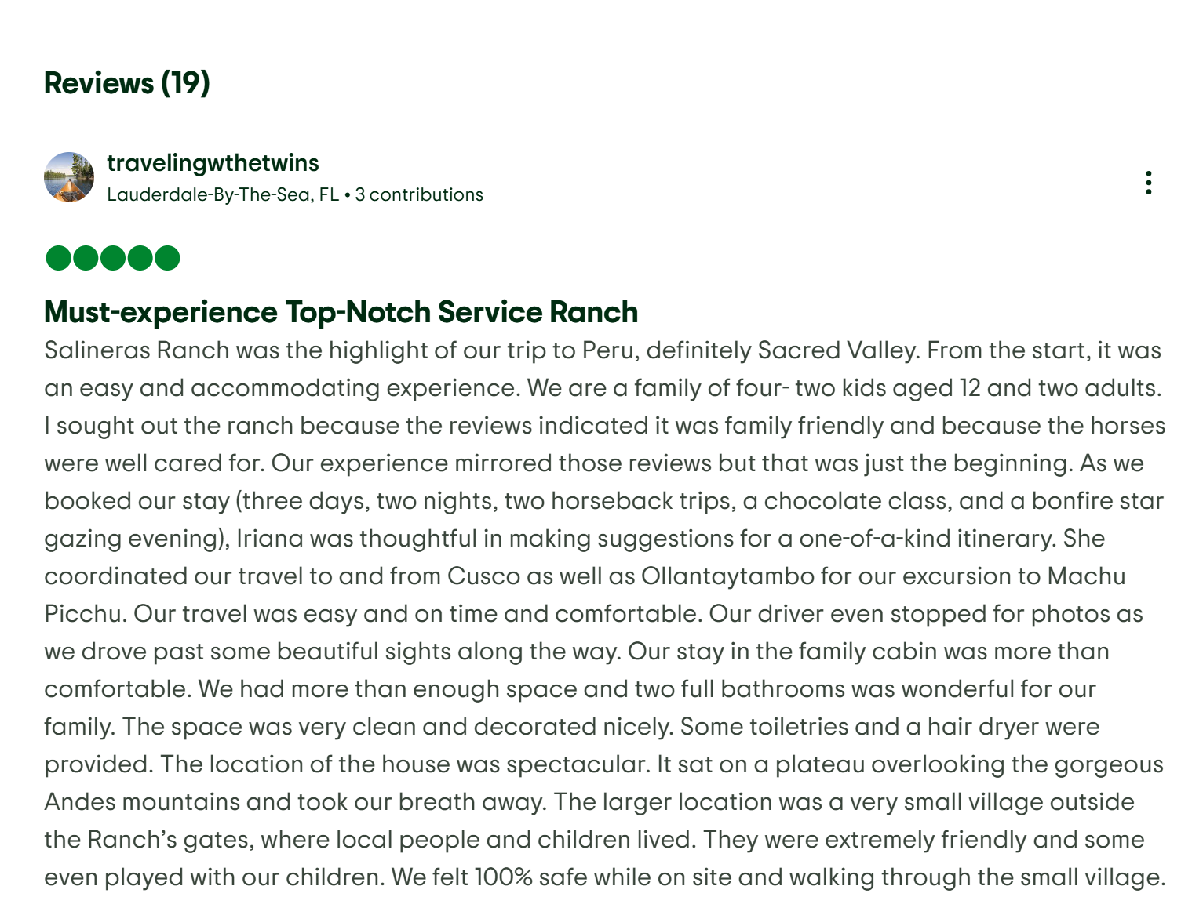
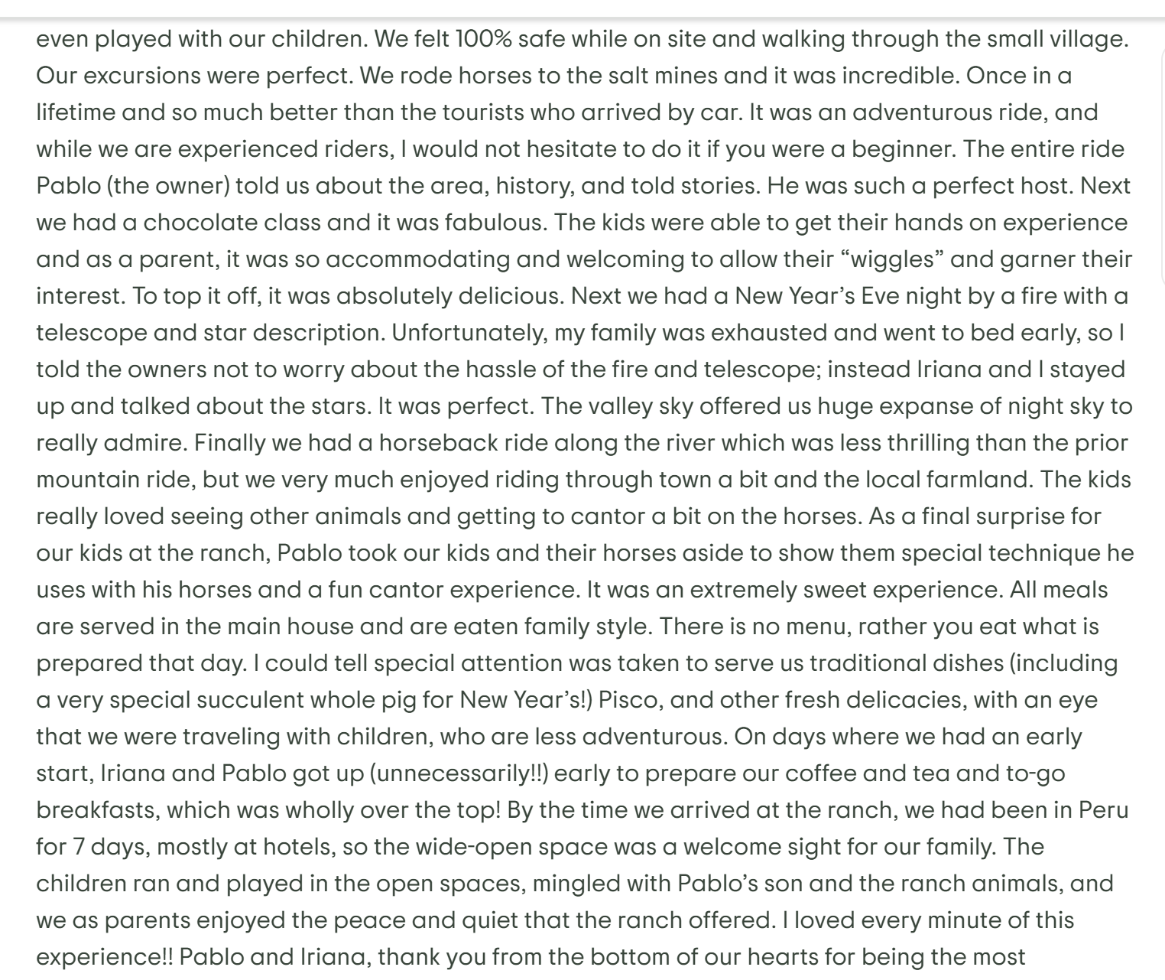
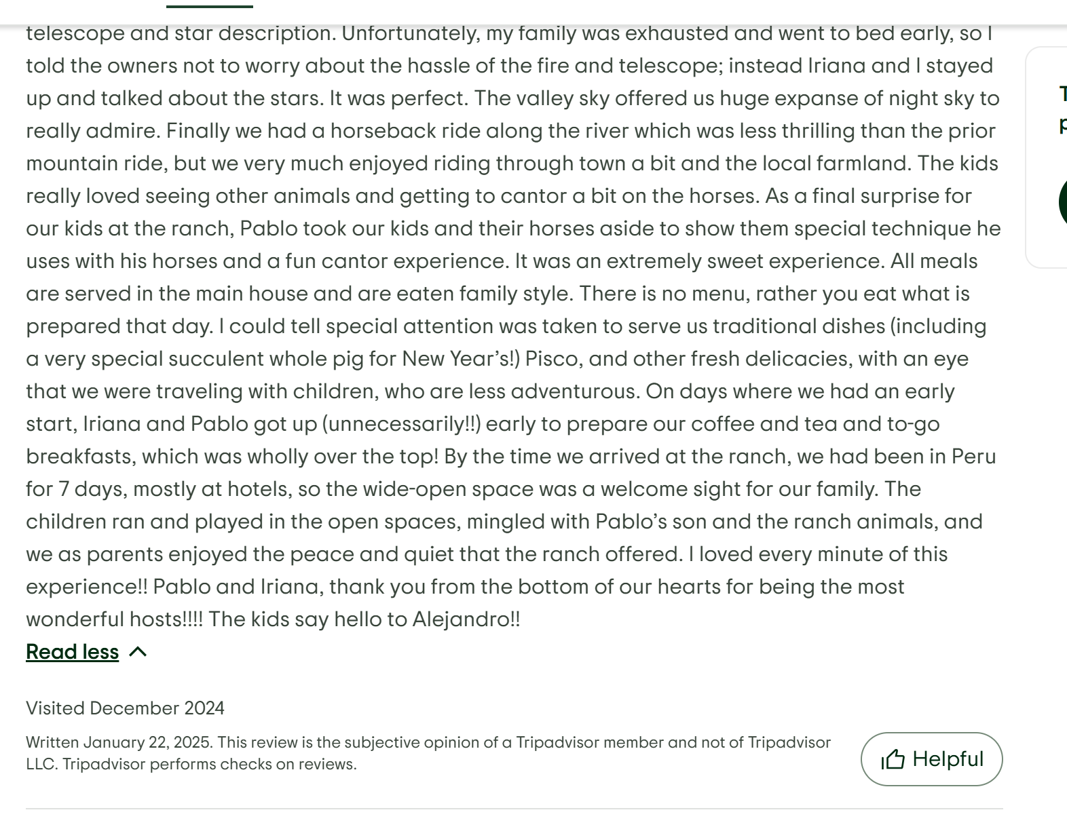

Must-experience Top-Notch Service Ranch
Salineras Ranch was the highlight of our trip to Peru, definitely Sacred Valley. From the start, it was an easy and accommodating experience. We are a family of four- two kids aged 12 and two adults. I sought out the ranch because the reviews indicated it was family friendly and because the horses were well cared for. Our experience mirrored those reviews but that was just the beginning. As we booked our stay (three days, two nights, two horseback trips, a chocolate class, and a bonfire star gazing evening), Iriana was thoughtful in making suggestions for a one-of-a-kind itinerary. She coordinated our travel to and from Cusco as well as Ollantaytambo for our excursion to Machu Picchu. Our travel was easy and on time and comfortable. Our driver even stopped for photos as we drove past some beautiful sights along the way. Our stay in the family cabin was more than comfortable. We had more than enough space and two full bathrooms was wonderful for our family. The space was very clean and decorated nicely. Some toiletries and a hair dryer were provided. The location of the house was spectacular. It sat on a plateau overlooking the gorgeous Andes mountains and took our breath away. The larger location was a very small village outside the Ranch’s gates, where local people and children lived. They were extremely friendly and some even played with our children. We felt 100% safe while on site and walking through the small village. Our excursions were perfect. We rode horses to the salt mines and it was incredible. Once in a lifetime and so much better than the tourists who arrived by car. It was an adventurous ride, and while we are experienced riders, I would not hesitate to do it if you were a beginner. The entire ride Pablo (the owner) told us about the area, history, and told stories. He was such a perfect host. Next we had a chocolate class and it was fabulous. The kids were able to get their hands on experience and as a parent, it was so accommodating and welcoming to allow their “wiggles” and garner their interest. To top it off, it was absolutely delicious. Next we had a New Year’s Eve night by a fire with a telescope and star description. Unfortunately, my family was exhausted and went to bed early, so I told the owners not to worry about the hassle of the fire and telescope; instead Iriana and I stayed up and talked about the stars. It was perfect. The valley sky offered us huge expanse of night sky to really admire. Finally we had a horseback ride along the river which was less thrilling than the prior mountain ride, but we very much enjoyed riding through town a bit and the local farmland. The kids really loved seeing other animals and getting to cantor a bit on the horses. As a final surprise for our kids at the ranch, Pablo took our kids and their horses aside to show them special technique he uses with his horses and a fun cantor experience. It was an extremely sweet experience. All meals are served in the main house and are eaten family style. There is no menu, rather you eat what is prepared that day. I could tell special attention was taken to serve us traditional dishes (including a very special succulent whole pig for New Year’s!) Pisco, and other fresh delicacies, with an eye that we were traveling with children, who are less adventurous. On days where we had an early start, Iriana and Pablo got up (unnecessarily!!) early to prepare our coffee and tea and to-go breakfasts, which was wholly over the top! By the time we arrived at the ranch, we had been in Peru for 7 days, mostly at hotels, so the wide-open space was a welcome sight for our family. The children ran and played in the open spaces, mingled with Pablo’s son and the ranch animals, and we as parents enjoyed the peace and quiet that the ranch offered. I loved every minute of this experience!! Pablo and Iriana, thank you from the bottom of our hearts for being the most wonderful hosts!!!! The kids say hello to Alejandro!!

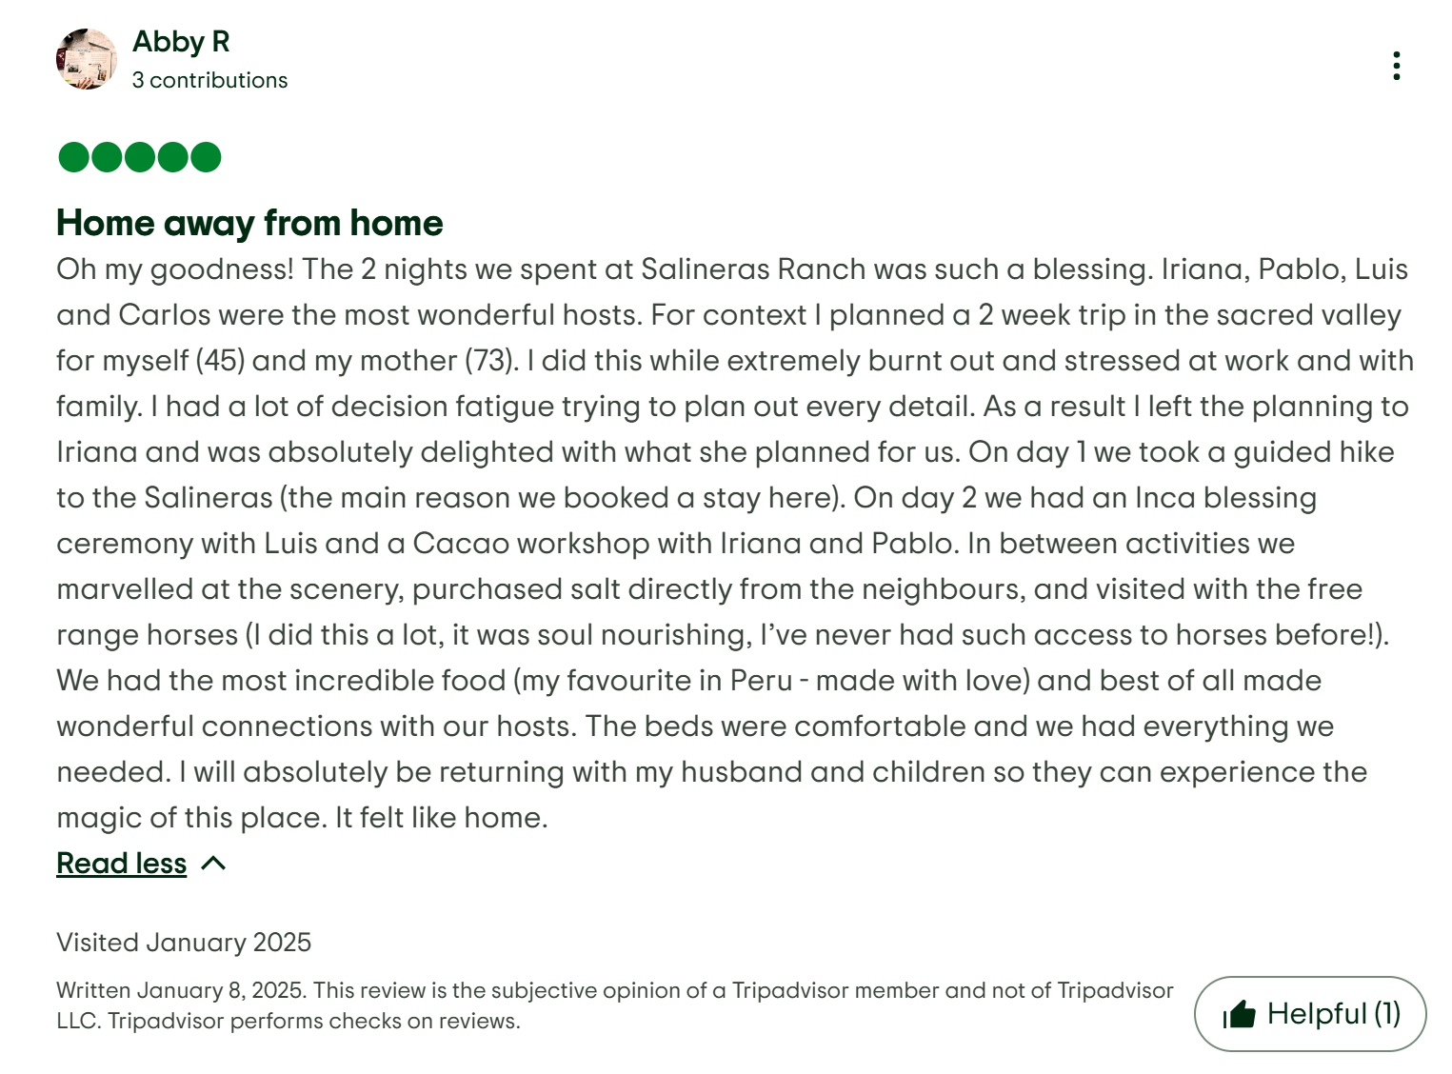

Home away from home
Oh my goodness! The 2 nights we spent at Salineras Ranch was such a blessing. Iriana, Pablo, Luis and Carlos were the most wonderful hosts. For context I planned a 2 week trip in the sacred valley for myself (45) and my mother (73). I did this while extremely burnt out and stressed at work and with family. I had a lot of decision fatigue trying to plan out every detail. As a result I left the planning to Iriana and was absolutely delighted with what she planned for us. On day 1 we took a guided hike to the Salineras (the main reason we booked a stay here). On day 2 we had an Inca blessing ceremony with Luis and a Cacao workshop with Iriana and Pablo. In between activities we marvelled at the scenery, purchased salt directly from the neighbours, and visited with the free range horses (I did this a lot, it was soul nourishing, I’ve never had such access to horses before!). We had the most incredible food (my favourite in Peru - made with love) and best of all made wonderful connections with our hosts. The beds were comfortable and we had everything we needed. I will absolutely be returning with my husband and children so they can experience the magic of this place. It felt like home.

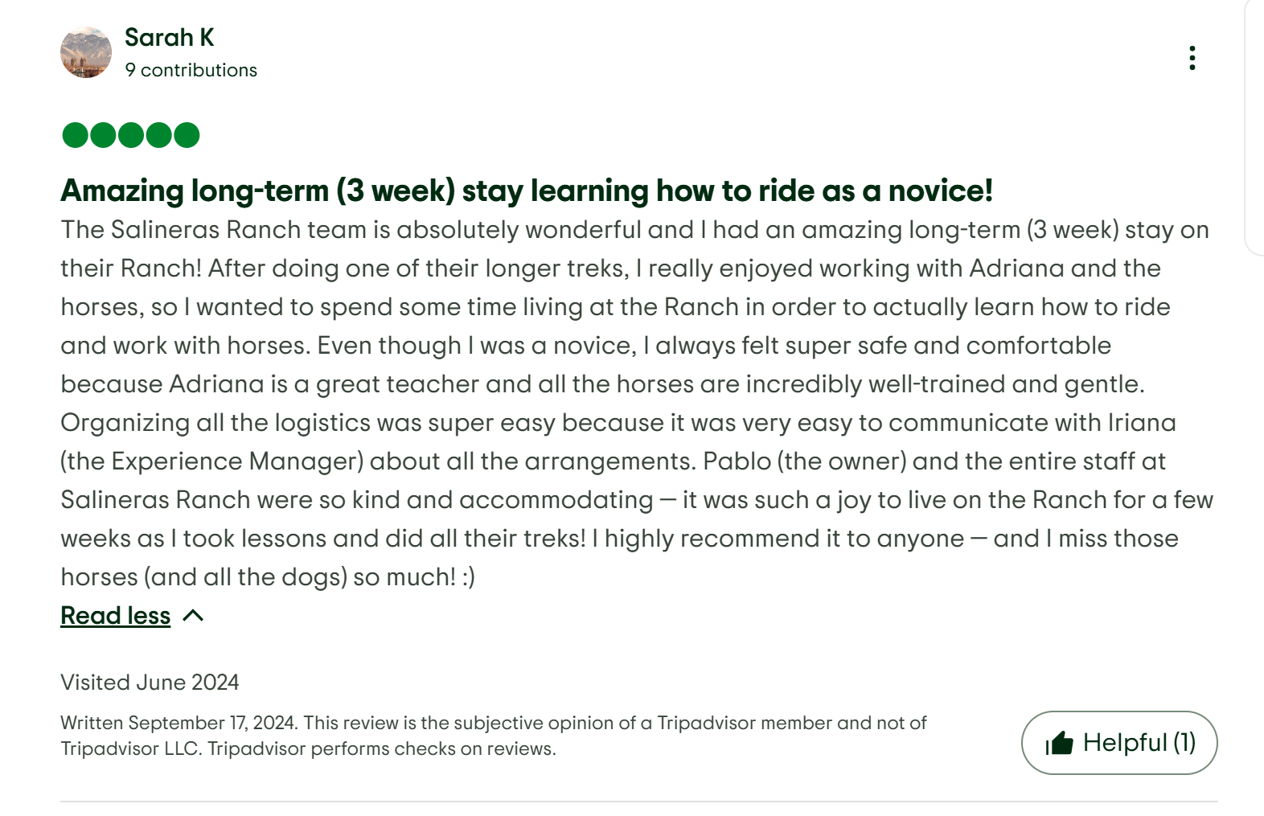

Amazing long-term (3 week) stay learning how to ride as a novice!
The Salineras Ranch team is absolutely wonderful and I had an amazing long-term (3 week) stay on their Ranch! After doing one of their longer treks, I really enjoyed working with Adriana and the horses, so I wanted to spend some time living at the Ranch in order to actually learn how to ride and work with horses. Even though I was a novice, I always felt super safe and comfortable because Adriana is a great teacher and all the horses are incredibly well-trained and gentle. Organizing all the logistics was super easy because it was very easy to communicate with Iriana (the Experience Manager) about all the arrangements. Pablo (the owner) and the entire staff at Salineras Ranch were so kind and accommodating — it was such a joy to live on the Ranch for a few weeks as I took lessons and did all their treks! I highly recommend it to anyone — and I miss those horses (and all the dogs) so much! :)

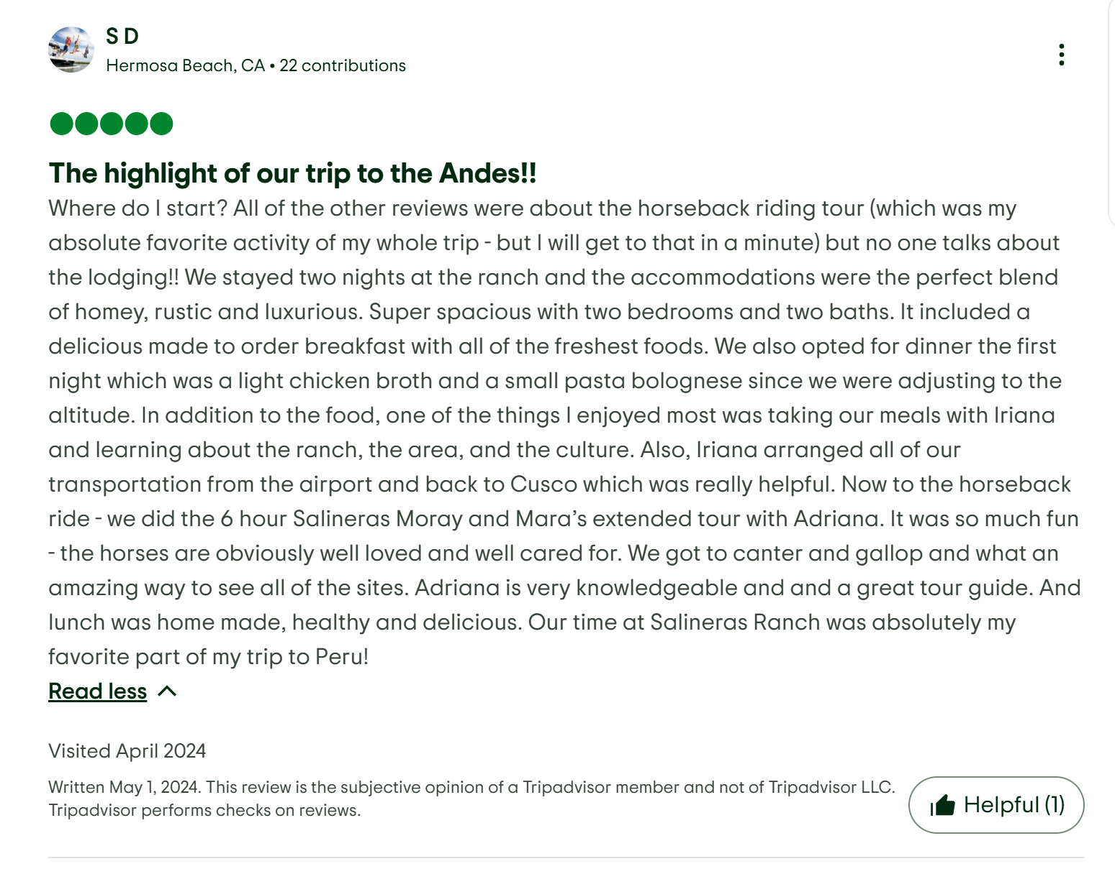

The highlight of our trip to the Andes!!
Where do I start? All of the other reviews were about the horseback riding tour (which was my absolute favorite activity of my whole trip - but I will get to that in a minute) but no one talks about the lodging!! We stayed two nights at the ranch and the accommodations were the perfect blend of homey, rustic and luxurious. Super spacious with two bedrooms and two baths. It included a delicious made to order breakfast with all of the freshest foods. We also opted for dinner the first night which was a light chicken broth and a small pasta bolognese since we were adjusting to the altitude. In addition to the food, one of the things I enjoyed most was taking our meals with Iriana and learning about the ranch, the area, and the culture. Also, Iriana arranged all of our transportation from the airport and back to Cusco which was really helpful. Now to the horseback ride - we did the 6 hour Salineras Moray and Mara’s extended tour with Adriana. It was so much fun - the horses are obviously well loved and well cared for. We got to canter and gallop and what an amazing way to see all of the sites. Adriana is very knowledgeable and and a great tour guide. And lunch was home made, healthy and delicious. Our time at Salineras Ranch was absolutely my favorite part of my trip to Peru!

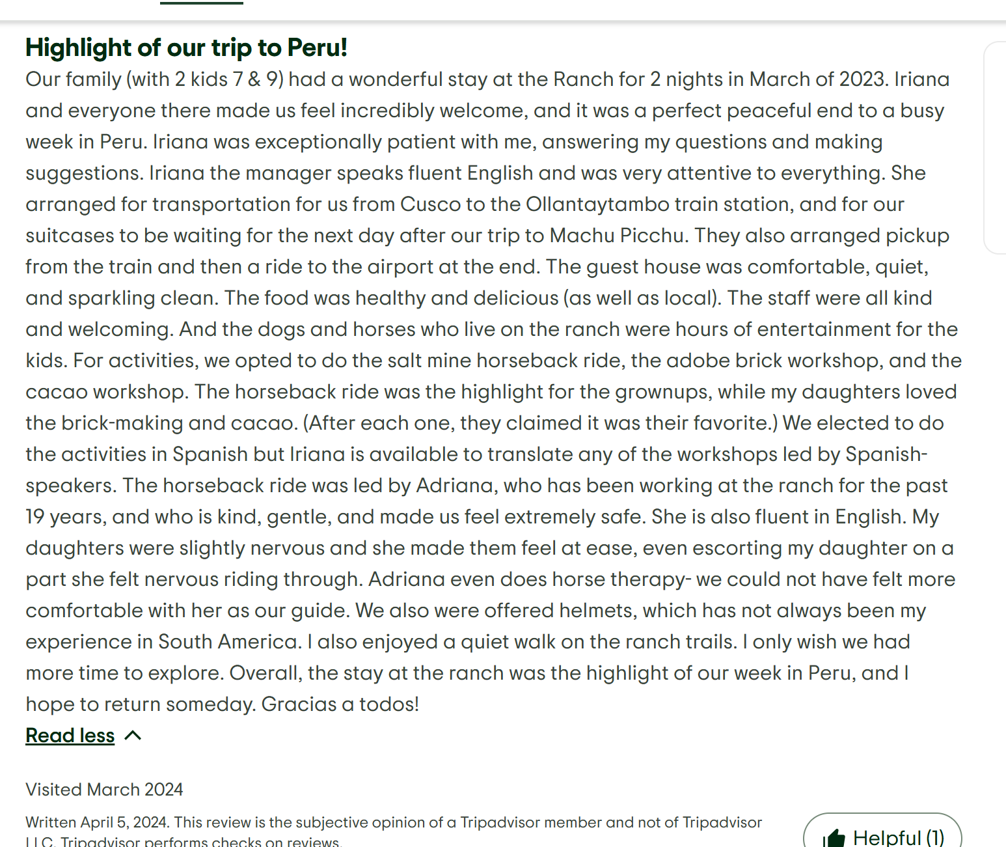

Highlight of our trip to Peru!
Our family (with 2 kids 7 & 9) had a wonderful stay at the Ranch for 2 nights in March of 2023. Iriana and everyone there made us feel incredibly welcome, and it was a perfect peaceful end to a busy week in Peru. Iriana was exceptionally patient with me, answering my questions and making suggestions. Iriana the manager speaks fluent English and was very attentive to everything. She arranged for transportation for us from Cusco to the Ollantaytambo train station, and for our suitcases to be waiting for the next day after our trip to Machu Picchu. They also arranged pickup from the train and then a ride to the airport at the end. The guest house was comfortable, quiet, and sparkling clean. The food was healthy and delicious (as well as local). The staff were all kind and welcoming. And the dogs and horses who live on the ranch were hours of entertainment for the kids. For activities, we opted to do the salt mine horseback ride, the adobe brick workshop, and the cacao workshop. The horseback ride was the highlight for the grownups, while my daughters loved the brick-making and cacao. (After each one, they claimed it was their favorite.) We elected to do the activities in Spanish but Iriana is available to translate any of the workshops led by Spanish-speakers. The horseback ride was led by Adriana, who has been working at the ranch for the past 19 years, and who is kind, gentle, and made us feel extremely safe. She is also fluent in English. My daughters were slightly nervous and she made them feel at ease, even escorting my daughter on a part she felt nervous riding through. Adriana even does horse therapy- we could not have felt more comfortable with her as our guide. We also were offered helmets, which has not always been my experience in South America. I also enjoyed a quiet walk on the ranch trails. I only wish we had more time to explore. Overall, the stay at the ranch was the highlight of our week in Peru, and I hope to return someday. Gracias a todos!

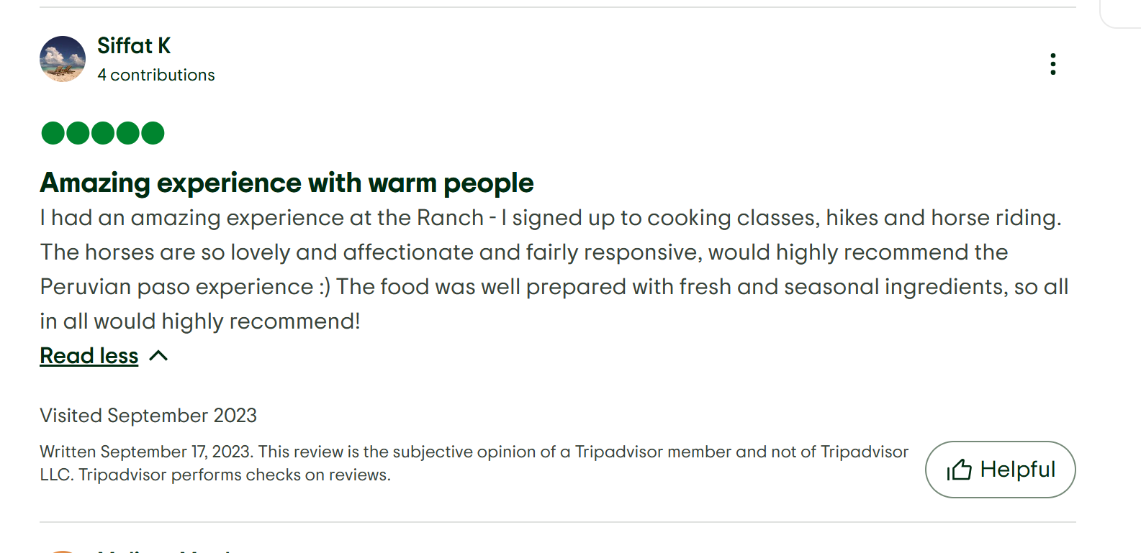

Amazing experience with warm people
I had an amazing experience at the Ranch - I signed up to cooking classes, hikes and horse riding. The horses are so lovely and affectionate and fairly responsive, would highly recommend the Peruvian paso experience :) The food was well prepared with fresh and seasonal ingredients, so all in all would highly recommend!

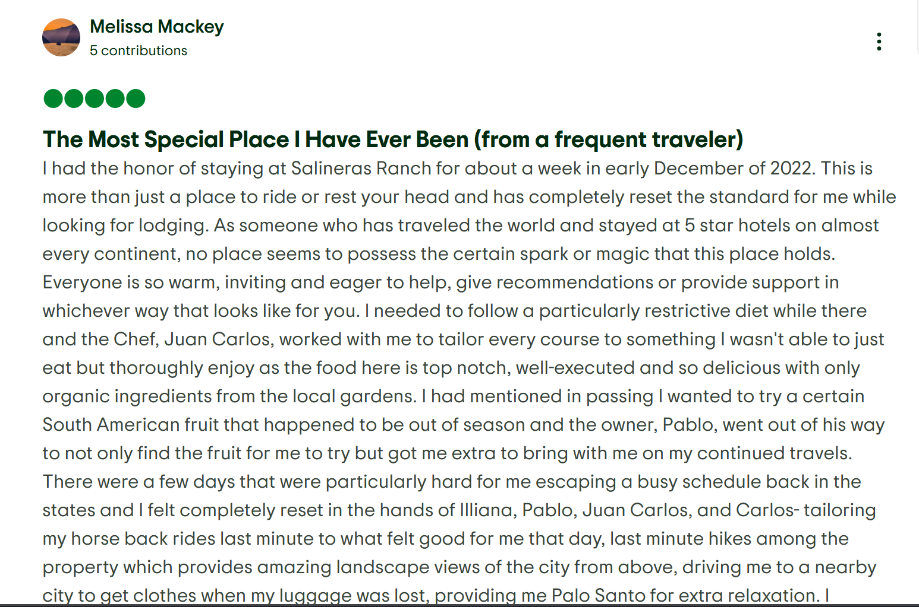

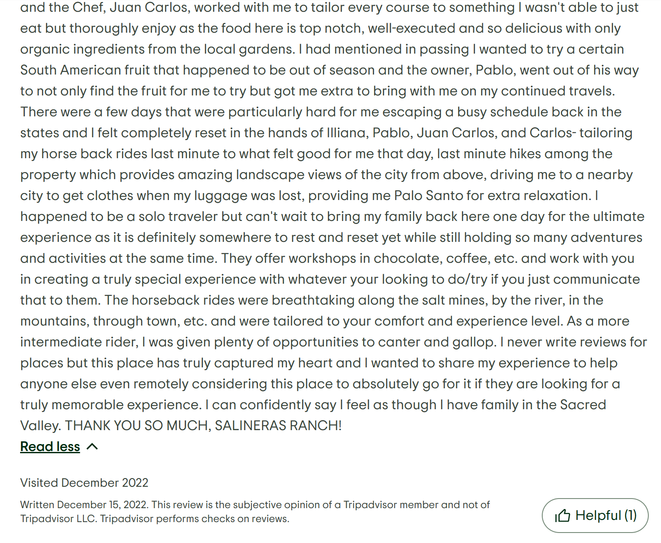

The Most Special Place I Have Ever Been (from a frequent traveler)
I had the honor of staying at Salineras Ranch for about a week in early December of 2022. This is more than just a place to ride or rest your head and has completely reset the standard for me while looking for lodging. As someone who has traveled the world and stayed at 5 star hotels on almost every continent, no place seems to possess the certain spark or magic that this place holds. Everyone is so warm, inviting and eager to help, give recommendations or provide support in whichever way that looks like for you. I needed to follow a particularly restrictive diet while there and the Chef, Juan Carlos, worked with me to tailor every course to something I wasn't able to just eat but thoroughly enjoy as the food here is top notch, well-executed and so delicious with only organic ingredients from the local gardens. I had mentioned in passing I wanted to try a certain South American fruit that happened to be out of season and the owner, Pablo, went out of his way to not only find the fruit for me to try but got me extra to bring with me on my continued travels. There were a few days that were particularly hard for me escaping a busy schedule back in the states and I felt completely reset in the hands of Illiana, Pablo, Juan Carlos, and Carlos- tailoring my horse back rides last minute to what felt good for me that day, last minute hikes among the property which provides amazing landscape views of the city from above, driving me to a nearby city to get clothes when my luggage was lost, providing me Palo Santo for extra relaxation. I happened to be a solo traveler but can't wait to bring my family back here one day for the ultimate experience as it is definitely somewhere to rest and reset yet while still holding so many adventures and activities at the same time. They offer workshops in chocolate, coffee, etc. and work with you in creating a truly special experience with whatever your looking to do/try if you just communicate that to them. The horseback rides were breathtaking along the salt mines, by the river, in the mountains, through town, etc. and were tailored to your comfort and experience level. As a more intermediate rider, I was given plenty of opportunities to canter and gallop. I never write reviews for places but this place has truly captured my heart and I wanted to share my experience to help anyone else even remotely considering this place to absolutely go for it if they are looking for a truly memorable experience. I can confidently say I feel as though I have family in the Sacred Valley. THANK YOU SO MUCH, SALINERAS RANCH!
Read less
Visited December 2022
Written December 15, 2022. This review is the subjective opinion of a Tripadvisor member and not of Tripadvisor LLC. Tripadvisor performs checks on reviews.

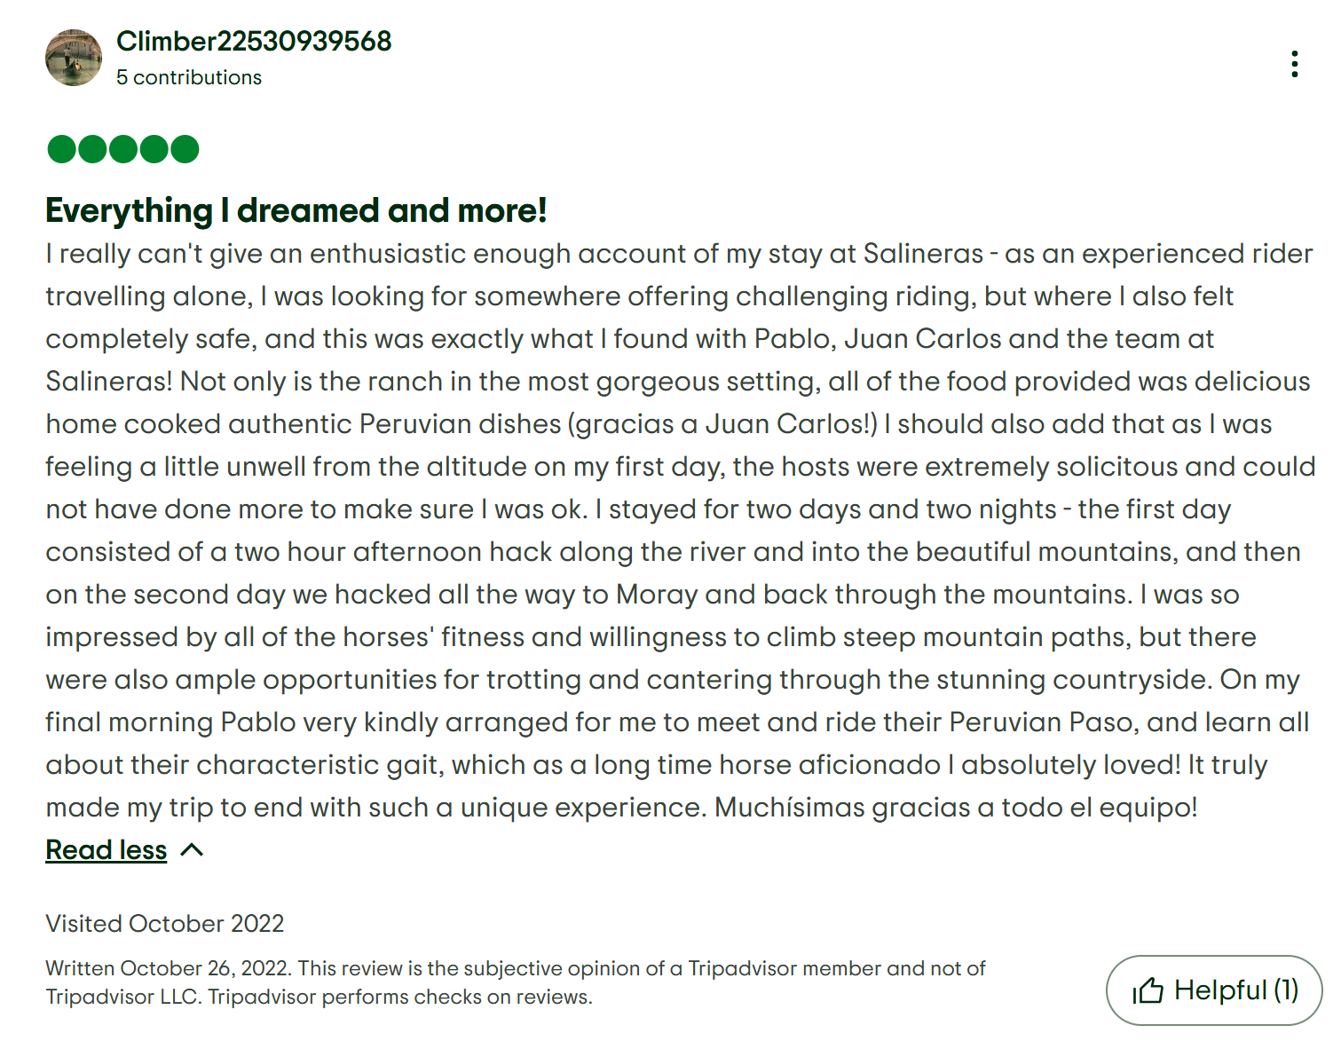

Everything I dreamed and more!
I really can't give an enthusiastic enough account of my stay at Salineras - as an experienced rider travelling alone, I was looking for somewhere offering challenging riding, but where I also felt completely safe, and this was exactly what I found with Pablo, Juan Carlos and the team at Salineras! Not only is the ranch in the most gorgeous setting, all of the food provided was delicious home cooked authentic Peruvian dishes (gracias a Juan Carlos!) I should also add that as I was feeling a little unwell from the altitude on my first day, the hosts were extremely solicitous and could not have done more to make sure I was ok. I stayed for two days and two nights - the first day consisted of a two hour afternoon hack along the river and into the beautiful mountains, and then on the second day we hacked all the way to Moray and back through the mountains. I was so impressed by all of the horses' fitness and willingness to climb steep mountain paths, but there were also ample opportunities for trotting and cantering through the stunning countryside. On my final morning Pablo very kindly arranged for me to meet and ride their Peruvian Paso, and learn all about their characteristic gait, which as a long time horse aficionado I absolutely loved! It truly made my trip to end with such a unique experience. Muchísimas gracias a todo el equipo!
Read less
Visited October 2022
Written October 26, 2022. This review is the subjective opinion of a Tripadvisor member and not of Tripadvisor LLC. Tripadvisor performs checks on reviews.

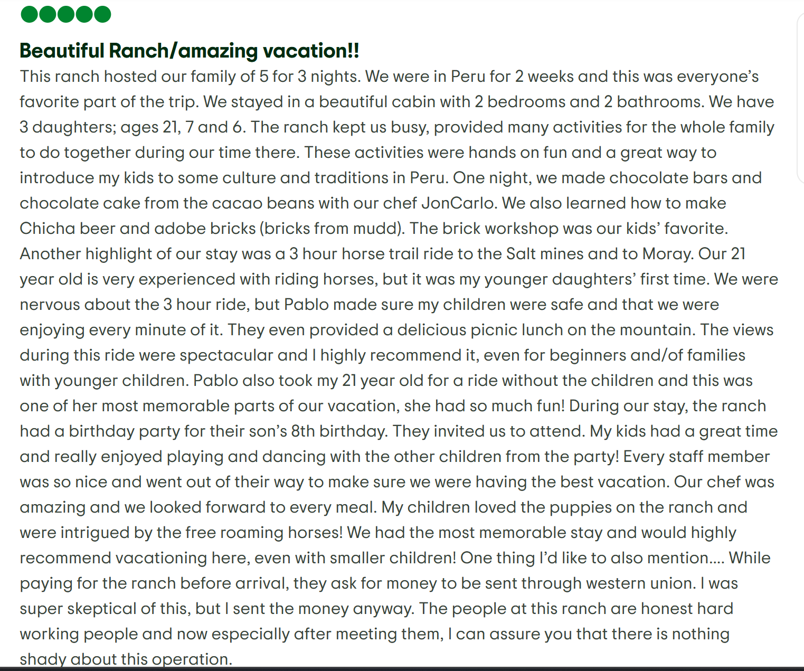

Beautiful Ranch/amazing vacation!!
This ranch hosted our family of 5 for 3 nights. We were in Peru for 2 weeks and this was everyone’s favorite part of the trip. We stayed in a beautiful cabin with 2 bedrooms and 2 bathrooms. We have 3 daughters; ages 21, 7 and 6. The ranch kept us busy, provided many activities for the whole family to do together during our time there. These activities were hands on fun and a great way to introduce my kids to some culture and traditions in Peru. One night, we made chocolate bars and chocolate cake from the cacao beans with our chef JonCarlo. We also learned how to make Chicha beer and adobe bricks (bricks from mudd). The brick workshop was our kids’ favorite. Another highlight of our stay was a 3 hour horse trail ride to the Salt mines and to Moray. Our 21 year old is very experienced with riding horses, but it was my younger daughters’ first time. We were nervous about the 3 hour ride, but Pablo made sure my children were safe and that we were enjoying every minute of it. They even provided a delicious picnic lunch on the mountain. The views during this ride were spectacular and I highly recommend it, even for beginners and/of families with younger children. Pablo also took my 21 year old for a ride without the children and this was one of her most memorable parts of our vacation, she had so much fun! During our stay, the ranch had a birthday party for their son’s 8th birthday. They invited us to attend. My kids had a great time and really enjoyed playing and dancing with the other children from the party! Every staff member was so nice and went out of their way to make sure we were having the best vacation. Our chef was amazing and we looked forward to every meal. My children loved the puppies on the ranch and were intrigued by the free roaming horses! We had the most memorable stay and would highly recommend vacationing here, even with smaller children! One thing I’d like to also mention…. While paying for the ranch before arrival, they ask for money to be sent through western union. I was super skeptical of this, but I sent the money anyway. The people at this ranch are honest hard working people and now especially after meeting them, I can assure you that there is nothing shady about this operation.
Read less
Visited September 2022
Written October 21, 2022. This review is the subjective opinion of a Tripadvisor member and not of Tripadvisor LLC. Tripadvisor performs checks on reviews.

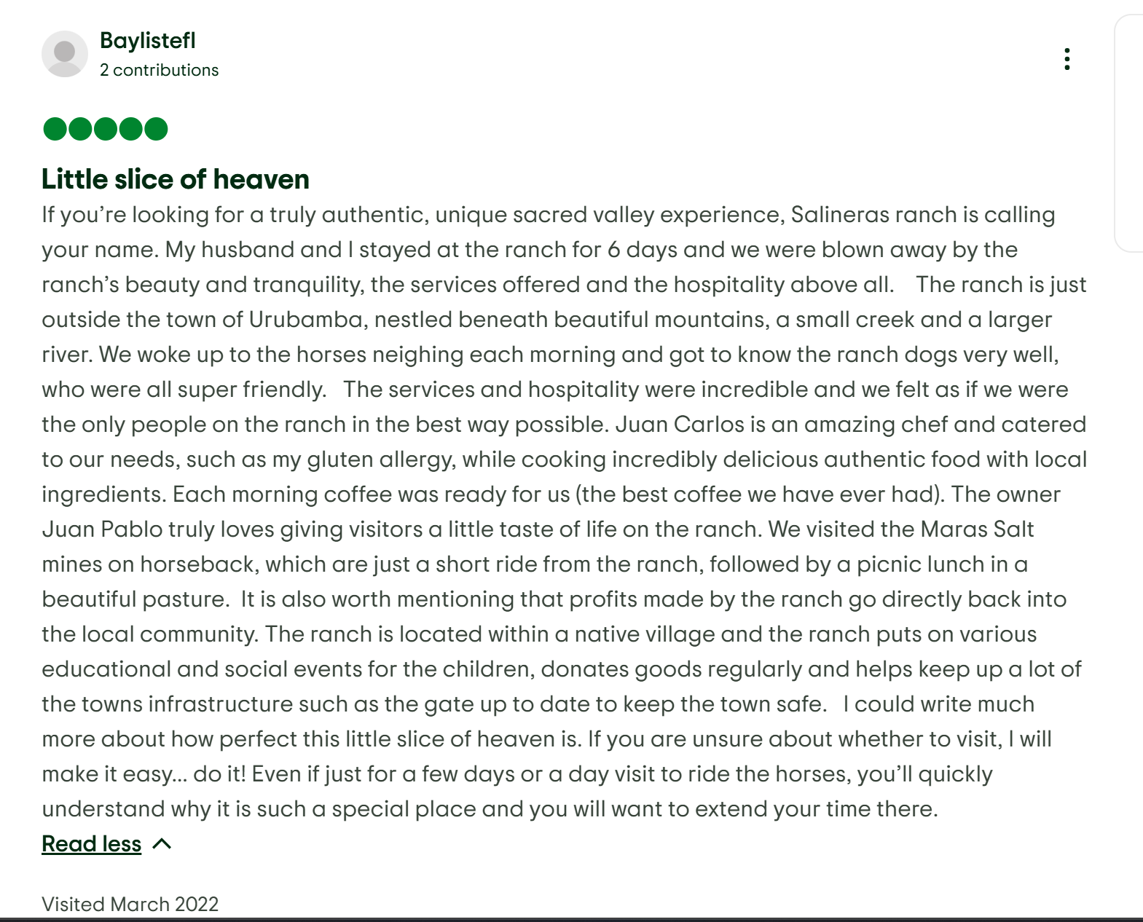

Little slice of heaven
If you’re looking for a truly authentic, unique sacred valley experience, Salineras ranch is calling your name. My husband and I stayed at the ranch for 6 days and we were blown away by the ranch’s beauty and tranquility, the services offered and the hospitality above all. The ranch is just outside the town of Urubamba, nestled beneath beautiful mountains, a small creek and a larger river. We woke up to the horses neighing each morning and got to know the ranch dogs very well, who were all super friendly. The services and hospitality were incredible and we felt as if we were the only people on the ranch in the best way possible. Juan Carlos is an amazing chef and catered to our needs, such as my gluten allergy, while cooking incredibly delicious authentic food with local ingredients. Each morning coffee was ready for us (the best coffee we have ever had). The owner Juan Pablo truly loves giving visitors a little taste of life on the ranch. We visited the Maras Salt mines on horseback, which are just a short ride from the ranch, followed by a picnic lunch in a beautiful pasture. It is also worth mentioning that profits made by the ranch go directly back into the local community. The ranch is located within a native village and the ranch puts on various educational and social events for the children, donates goods regularly and helps keep up a lot of the towns infrastructure such as the gate up to date to keep the town safe. I could write much more about how perfect this little slice of heaven is. If you are unsure about whether to visit, I will make it easy… do it! Even if just for a few days or a day visit to ride the horses, you’ll quickly understand why it is such a special place and you will want to extend your time there.
Read less
Visited March 2022
Written September 25, 2022. This review is the subjective opinion of a Tripadvisor member and not of Tripadvisor LLC. Tripadvisor performs checks on reviews.

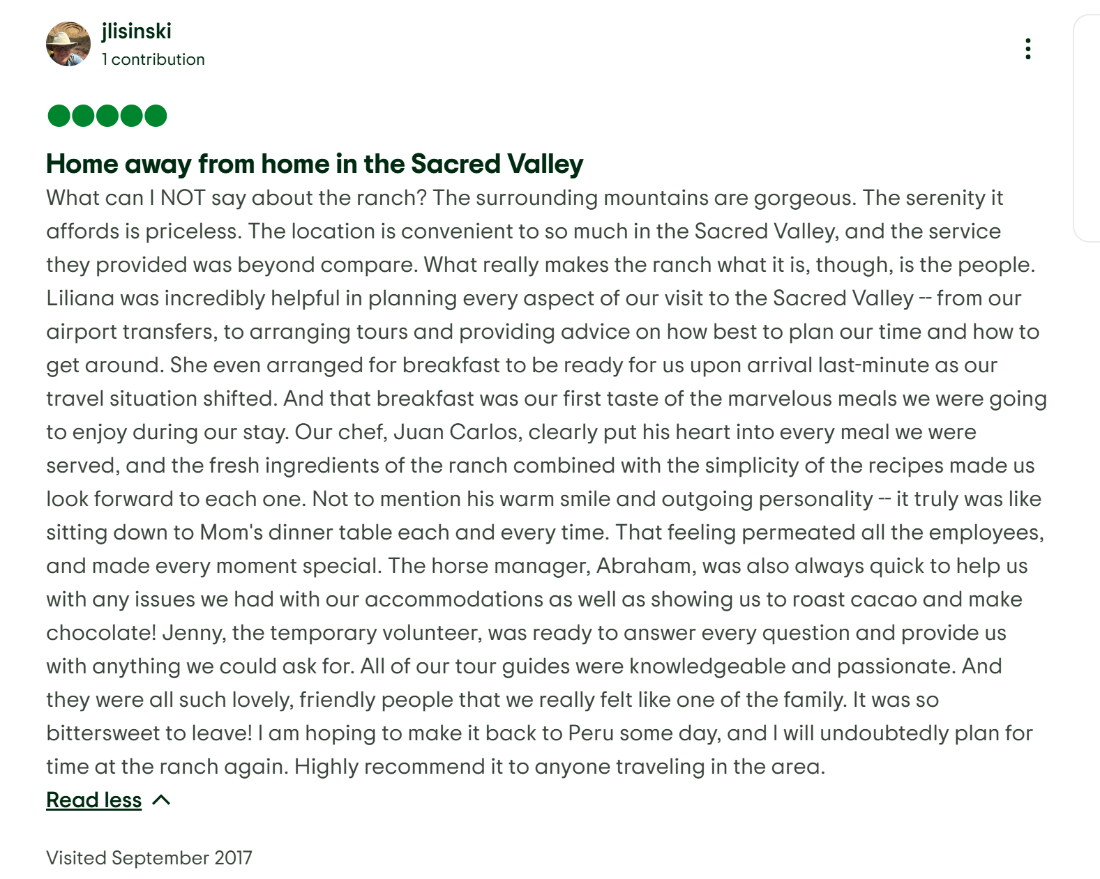

Home away from home in the Sacred Valley
What can I NOT say about the ranch? The surrounding mountains are gorgeous. The serenity it affords is priceless. The location is convenient to so much in the Sacred Valley, and the service they provided was beyond compare. What really makes the ranch what it is, though, is the people. Liliana was incredibly helpful in planning every aspect of our visit to the Sacred Valley -- from our airport transfers, to arranging tours and providing advice on how best to plan our time and how to get around. She even arranged for breakfast to be ready for us upon arrival last-minute as our travel situation shifted. And that breakfast was our first taste of the marvelous meals we were going to enjoy during our stay. Our chef, Juan Carlos, clearly put his heart into every meal we were served, and the fresh ingredients of the ranch combined with the simplicity of the recipes made us look forward to each one. Not to mention his warm smile and outgoing personality -- it truly was like sitting down to Mom's dinner table each and every time. That feeling permeated all the employees, and made every moment special. The horse manager, Abraham, was also always quick to help us with any issues we had with our accommodations as well as showing us to roast cacao and make chocolate! Jenny, the temporary volunteer, was ready to answer every question and provide us with anything we could ask for. All of our tour guides were knowledgeable and passionate. And they were all such lovely, friendly people that we really felt like one of the family. It was so bittersweet to leave! I am hoping to make it back to Peru some day, and I will undoubtedly plan for time at the ranch again. Highly recommend it to anyone traveling in the area.
Read less
Visited September 2017

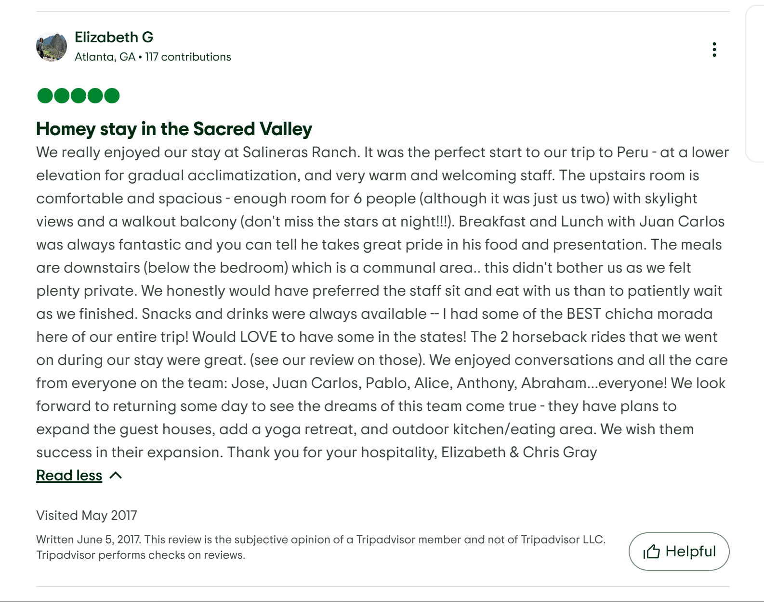

Homey stay in the Sacred Valley
We really enjoyed our stay at Salineras Ranch. It was the perfect start to our trip to Peru - at a lower elevation for gradual acclimatization, and very warm and welcoming staff. The upstairs room is comfortable and spacious - enough room for 6 people (although it was just us two) with skylight views and a walkout balcony (don't miss the stars at night!!!). Breakfast and Lunch with Juan Carlos was always fantastic and you can tell he takes great pride in his food and presentation. The meals are downstairs (below the bedroom) which is a communal area.. this didn't bother us as we felt plenty private. We honestly would have preferred the staff sit and eat with us than to patiently wait as we finished. Snacks and drinks were always available -- I had some of the BEST chicha morada here of our entire trip! Would LOVE to have some in the states! The 2 horseback rides that we went on during our stay were great. (see our review on those). We enjoyed conversations and all the care from everyone on the team: Jose, Juan Carlos, Pablo, Alice, Anthony, Abraham...everyone! We look forward to returning some day to see the dreams of this team come true - they have plans to expand the guest houses, add a yoga retreat, and outdoor kitchen/eating area. We wish them success in their expansion. Thank you for your hospitality, Elizabeth & Chris Gray
Read less
Visited May 2017
Written June 5, 2017. This review is the subjective opinion of a Tripadvisor member and not of Tripadvisor LLC. Tripadvisor performs checks on reviews.

